18MAB302T – Discrete Mathematics For Engineers
Unit – I: Set Theory

OBJECTIVE TYPE QUESTIONS

- A collection of all well defined objects is called
(a) set (b) group (c) coset (d) lattice
- An equivalence relation R on a set A is said to posses
(a) reflexive, antisymmetric and transitive (b) reflexive, symmetric and transitive
(c) reflexive, nonsymmetric and antisymmetric (d) none of these
- Relative complement of S with respect to R is defined as
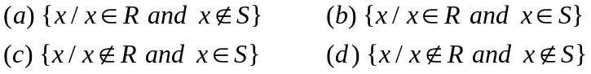
- If the relation R is reflexive, antisymmetric and transitive, then the relation R is called
(a) equivalence relation (b) equivalence class (c) partial order relation
(d) partially ordered set
- A digraph representing the partial order relation
(a) Helmut Hasse (b) POSET (c) graph relation (d) Hasse diagram
- In a poset, the maximum number of greatest and least members if they exist are
(a) more than one (b) unique (c) zero (d) exactly two
- Equivalence class of ‘a’ is defined by
- If A is a non-empty set with n elements, then number of possible relations on the set A is
(a) 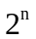 (b) 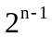 (c) 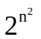 (d) 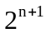
- Which one of the following relations on the set {1, 2, 3, 4} is an equivalent relation
(a) {(2,4), (4,2)} (b) {(2,2), (2,3), (2,4), (3,2), (3,3), (3,4)}
(c) {(1,3), (1,4), (2,3), (2,4), (3,1), (3,4)}(d) {(1,1), (1,2), (2,1), (2,2), (3,3), (4,4)}
- From each of the following relations, determine which is one of the relation is a partial order relation
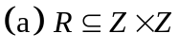 where aRb if a divides b (b) R is the relation on Z, where aRb if a + b is odd
(c) 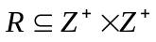, where aRb if a divides b (d) none of these.
- Determine which one of the following relations on the set {1, 2, 3, 4} is a function.
(a) 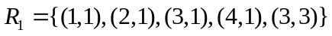 (b) 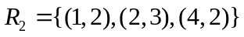
(c) 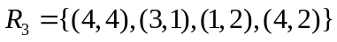 (d) 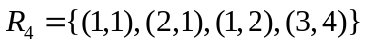
- How many possible functions we get 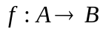, if 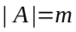 and 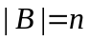
(a) (b) 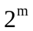 (c) 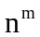 (d) 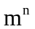
- If n pigeons are accommodated in m pigeon holes and n > m, then one of the pigeon holes must contain at least
(a) 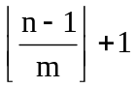 (b) 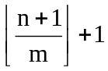 (c) 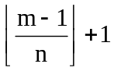 (d) 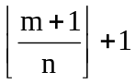
- In a group of 100 people, several will have birth days in the same month. At least how many must have birth days in the same month
(a) 10 (b) 8 (c) 9 (d) 12
- If 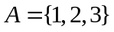 and f, g are functions from A to A given by f = {(1,2), (2,3), (3,1)}, g = {(1,2), (2,1), (3,3)} then {(1,3), (2,2), (3,1)} is the composition relation of one of the following:
- If 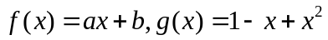 for , and 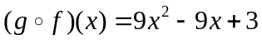. Find the values of a and b.
(a) a = 3, b = -1 (or) a = -3, b = 2 (b) a = 1, b = 3 (or) a = 1, b = 2
(c) a = -3, b = -1 (or) a = -3, b = 2 (d) a = 3, b = 2 (or) a = -3, b = -1
- How many different outcomes are possible when 5 dice are rolled?
(a) 250 (b) 256 (c) 252 (d) 225
- If there are 5 points inside a square of side length 2 then how many points can be there within a distance 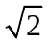 of each other.
(a) 3 (b) 4 (c) 5 (d) 2
- How many distinct 4 digit integers can one make from the digits 1, 3, 3, 7, 7 and 8?
(a) 70 (b) 90 (c) 80 (d) 75
- If 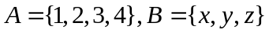 and 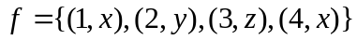, then the function f is
(a) both 1 – 1 and onto (b) 1 – 1 but not onto
(c) onto but not 1 – 1 (d) neither 1 – 1 nor onto

Answers

1. (a) 11. (a)
2. (b) 12. (c)
3. (a) 13. (a)
4. (c) 14. (c)
5. (b) 15. (a)
6. (b) 16. (a)
7. (a) 17. (c)
8. (c) 18. (d)
9. (d) 19. (b)
10.(c) 20. (c)

